**ARTIST BIOGRAPHY**

**PRYMË**

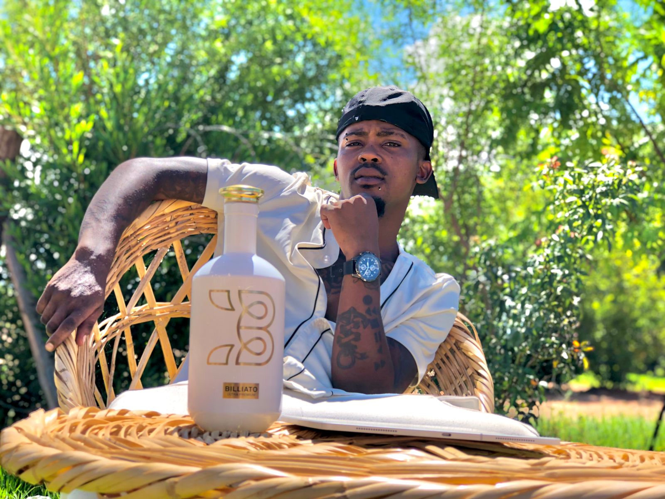

His-Story

Adrian Beukes goes by the stage name: Prymë.

Prymë is a young artist, rapper and song writer, he grew up and lived in Cape Town – Kraaifontein, before moving to Upington in the Northern Cape at the beginning of 2023. Prymë is a Hip/Hop artist and his style is mostly Trap Music but he don’t like being boxed in just one genre. When he began his music career at age 13, he looked up to Lil’ Wayne “I grew up listening to his music. The amount of work he puts in his craft is very impressive and he is the person I really look up too” and still till today, Lil’ Wayne is a major influence on Prymë, even the love Prymë has for tattoos is prove that Lil’ Wayne has a huge influence on him. When Prymë work on new music, he makes sure not to listen to other artist and he listens to his own music to improve on himself as he sees himself as his own competition.

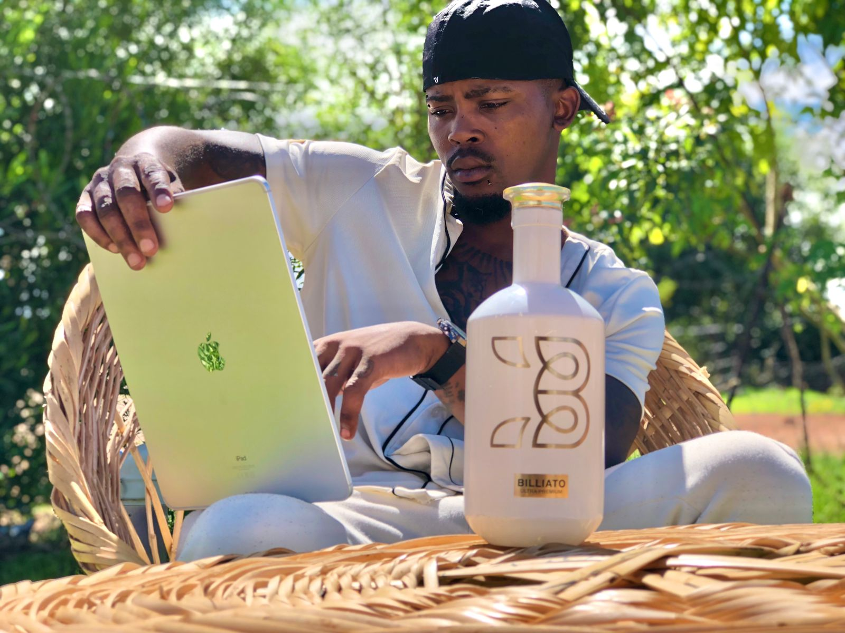

In March 2022 Prymë with of his friends released an Album title: ***Different***. The Artists on the Album is Prymë, MANNB & Servant Stone. The Album consists of 14 songs and was produced by Servant Stone. Production on the album took them a month to finish.

In December 2022, Prymë was in the Northern Cape - Upington for vacation but ended up working with DJ Lands on a project. They started recording the first song on the 25th December. The song is based on his best friend that passed away on the 15th of December, 2022. The song was released on the 6th January, 2023 the day his best got buried and the title of the song is: ***I WISH I HAD A CHANCE***.

Prymë and DJ Lands are currently working on a full-length album, that’s due for release in 2023.

**Performance**

Prymë performed at events such as Café Wallacedene, Adwa Café and V3 Curve to name a few.

**Interviews**

Prymë have been interviewed by CTV (Cape Town Television) and have launched hisfirst project Black Kullid at CTV.